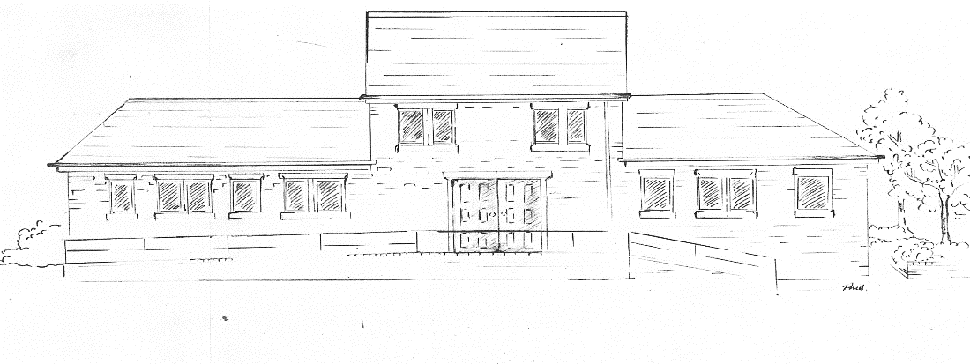TRINITYMEDICAL CENTRE

**Welcome to Trinity Medical Centre** our surgery opening times are as follows:

Monday: 8am – 6:30pm

Tueday: 8am – 6:30pm

Wednesday: 8am – 6:30pm

Thursday: 7:30am – 6:30

Friday: 8am – 6:30pm

We offer a variety of appointments at Trinity Medical Centre, these can be on on or off site, you will be signposted by the Administration team to the most appropriate service for your needs. This can include appointments at external clinics where you will see a GP, the clinics could either be Whitehall Street Clinic near Rochdale Infirmary or Littleborough Group Practice, as we often have access to a GP at Littleborough Group Practice. The appointements at one of these services will be a booked appointment, so you will be given a time to attend.

We offer chronic disease management with one of our experienced clinicians.

We offer Childhood Immunisations along with mother and baby checks for new babies.

We can book appointments for Cervial Screening to be completed.

If you have any queries in relation to the services we offer, you can look at our website <https://trinitymedicalcentre.org.uk> or contact us on 01706 378 476 for more information.

TRINITYMEDICAL CENTRE

We can take prescription requests via the following routes:

Patchs – which can be found on our website

Email – [gmicb-hmr.trinitymedicalcentre@nhs.net](mailto:gmicb-hmr.trinitymedicalcentre@nhs.net)

Pop into the sugery

Please note – we NO LONGER take prescription requests via the telephone.

**The GP Team The Nurse Team**

Dr David Brazier – Partner GP (M) Paula Brazier - Practice Nurse

Dr Marc Handford - Partner GP (M) Jane Reynolds – Practice Nurse

Dr Zalan Alam - Partner GP (M) Victoria Curtis – Practice Nurse

Dr Deborah Barton – Salaried GP (F) Janine Rochardson – Assistant

Zaeema Hanif – Trainee GP (F) Practitioner

**Additional Roles**

Bart – Paramedic (M) Michelle – Paramedic (F) Beth – Pharamcist (F)

**Administration Team**

Lucy Hepworth- Practice Manager Emily Law – Care Co-ordinator

Isabel Coltas – Deputy PM Kirsten Hopkinson – Administrator

Monica Wallace - Administrator Adele Wroe - Administrator

Karen Burns – Administrator Samara Matthews – Administrator

Letitia Hurst – Administrator