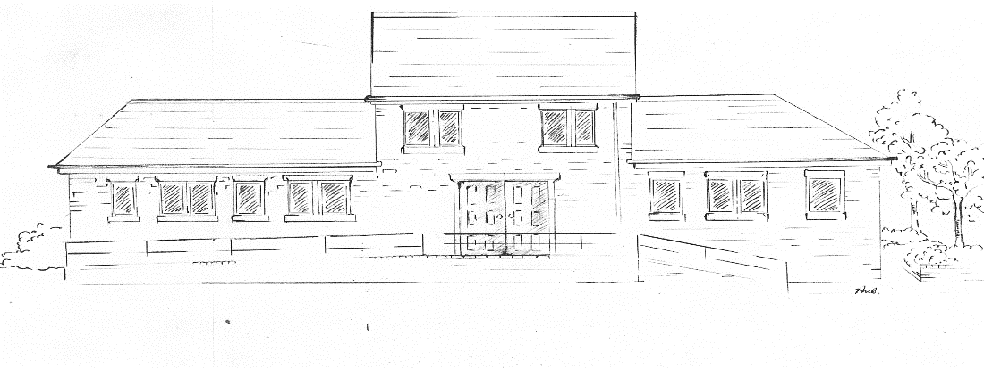

T R I N I T Y M E D I C A L
C E N T R E

Flu Vaccinations are available every autumn – we will make contact with all our eligible patients from September onwards who are entitled to a free flu vaccine. Flu vaccinations are particularly important for patients with chronic diseases such as chest problems, heart disease and diabetes, it is also important for our elderly patients and patients who are carers, if you do not receive a recall, please contact the surgery and book your appointment, while we do endeavour to contact all patients, sometimes we have incorrect phone numbers or the message may not arrive.

Flu vaccinations for children aged 2-4 years of age can be given at the GP surgery. There may also be specific age ranges for those in an at-risk group which can be given at the GP surgery. You will be notified if your child is entitled to a flu vaccination at the Trinity Medical Centre.

Other Immunisations: Pneumonia, We offer Pneumonia vaccinations. This is for those patients who are aged 65 and over but also for certain people who have a Chronic condition like heart problems, chest conditions, diabetes etc. If you are unsure if you have had one please get in touch. Most people only have this once in a lifetime.

Shingles vaccines are offered mostly to those patients that have turned 65 on or after 1st September up until they are 79. Everyone from age 70 – 79 regardless or date of birth are eligible. Some patients are deemed vulnerable due to being immunocompromised due to medication or an underlying medical condition are eligible from age 50 onwards. If you think you are eligible, please contact the surgery to check.

